Serena Migdal

CS110

Prof. Kevin Ryan

12/13/2020

**Project Report**

For my program, I wanted to look at the top S&P 500 stocks of the past decade. I was interested in how drastic a stock's performance can change in just the span of a year or two. In my program I compare the top 10 stocks of a few years in the 2010’s, up to the user’s decision. I specifically compared the most recent year’s performance to a year of the past, having the output focus on the closer year’s stocks. I also have the option to display the CSV file information for each year.

I used IDLE as my user interface for python.

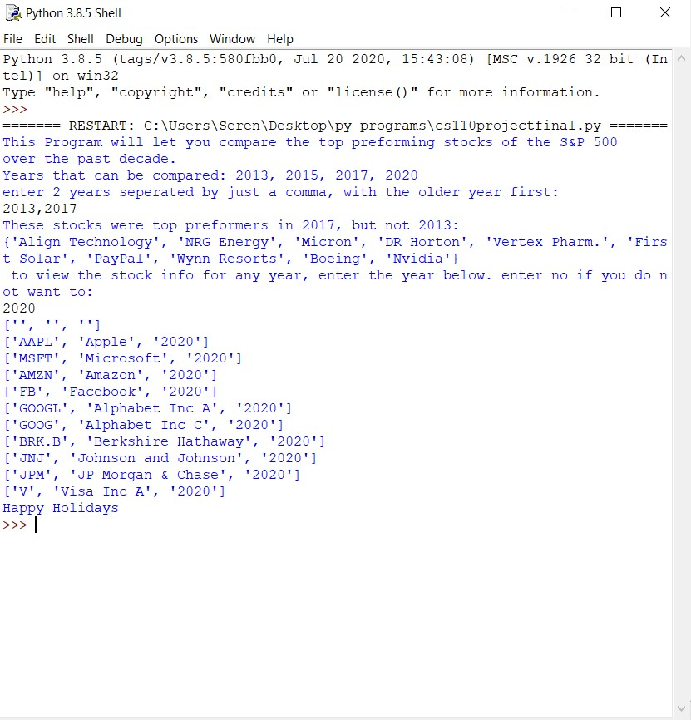

This is a sample input and output of my program.

**Target Audience**

A user of my program would be somebody interested in the stock market. The user would also be interested in the statistics of how certain stocks perform each year.

Another idea of my project was to take 10 stocks and compare their performances during different years.

**Specific Programming Techniques**

The most prominent technique used were if-elif statements. For each combination of years I used that type of statement to compare. I used lists with the append function to display certain rows in my for loops for each year wanted.

I changed the lists to sets for the output displays so I could conduct the comparison. I used the math library for the ‘.difference’ tool to subtract one years stock names from the others.

I collected data from different sources online. My initial plan was to take all 500+ stocks from a few years in the past decade and compare to see which stocks were added/unadded each year. To my surprise, that sort of data is not open for use on the S and P 500 index site or any sites for that matter. I had access to the top 10’s, so I just manually entered that data into a table and turned it into CSV files.

**Challenges**

Mentioned above was the first issue I ran into. I tried doing the comparison with the difference function when I had the data in lists. That didn't work, so I made them into sets and it worked. I used the ‘with open’ tool stead of ‘open()’ because to my understanding I could manipulate a file with ‘with open’ and not ‘open()’. I used the open() tool in my second defined function, “main1”.

**Future Extensions**

If I were to extend this program, I would add more stock data to each year’s csv files. With this I could possibly plot different metrics, like percent growth each year, change in stock price, earnings, ect. I would also add more years, like the whole decade, to get an even clearer picture of the comparison of performances each year.

